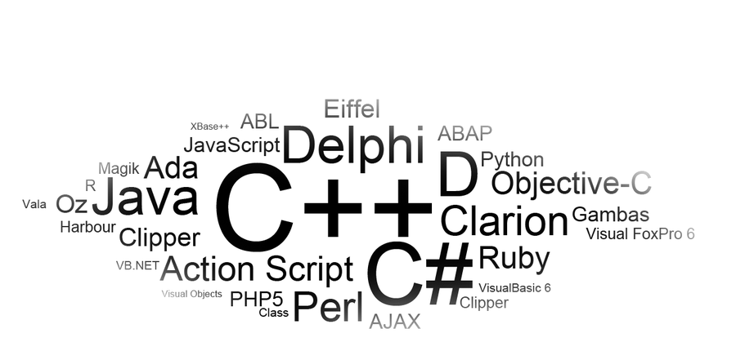




Recent Discussions

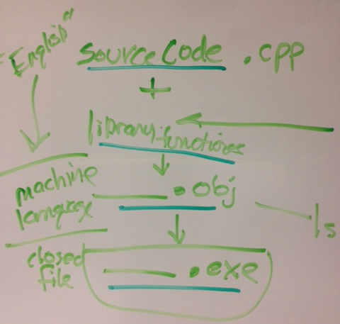
When you type programming code you are creating a SOURCE CODE file you save with a .cpp file extension so the computer recognizes it as C++ code. The computer cannot read C++ code. It needs machine language (1s and 0s). When you compile your code, part of what happens is you convert your Source Code to 1s and 0s creates an OBJECT FILE with an .obj file extension.

If your code has reserved words that instruct the computer to write the results of your program to the computer screen (cin) or accept typing from a keyboard (cout) or do math such as raising a number to a power (pow), then you must add code that someone else has written to show how “cin” or “cout” or “pow” works into your code. This additional code is stored in a function library. You include categories of this code in your program by typing “#include” and the name of the category, such as #include <iostream> instructing the computer how to handle input/output (io) commands like cin and cout. When a linker links this other code with yours the compiler turns your program into an EXECUTABLE FILE with an .exe file extension that can be run like any other program.

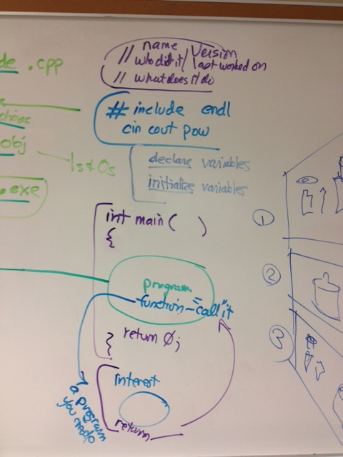
Remember that every C++ program that you write has a basic framework that contains the elements you need to run the program’s main function:
- Comments at the top note things such as who wrote the program, when, its version, and a brief description of what the program does.
- The next area includes the library functions that your program needs (using #include...).
- Somewhere in your program you must declare variables you have introduced in the code and initialize the value of a variable if needed.
- The main part of the program is always required. Right now we type ( ) and “return 0” at the end to indicate that we are not returning the value from any other function.
- Note that any time you have more than one statement in an area that you need { and }
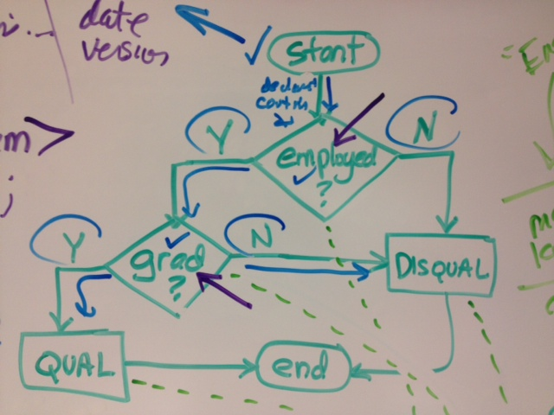
The flowchart is a tool used to outline the flow of logic in a program. Each of the symbols represents at least one statement (usually one line of code) in a program. Let us look at the flowchart to the left and what it represents:
- The START and END symbols are ovals. It is important to know where your program starts and to end it properly.
- A diamond shape is a decision – a branching structure with more than one direction of logic depending on the value of a condition --- in this case, the answer to “Are you employed?”
- The rectangular shape is an activity such as a formula. However, this one (in the flowchart above) should be a parallelogram, which symbolizes an input (cin) or output (cout).

How do you read the flowchart?
- START
- Decision: “Are you employed?” – answers are Yes (Y) or No (N)
  - If the answer to “Are you employed?” is Yes (Y) there is another Decision: “Did you graduate?”
    - If the answer to “Did you graduate?” is Yes (Y) then the output is “Qual(ified)”
    - If the answer to “Did you graduate?” is No (N) then the output is “Disqual(ified)”
  - If the answer to “Are you employed?” is No (N) then the output is “Disqual(ified)”
- END
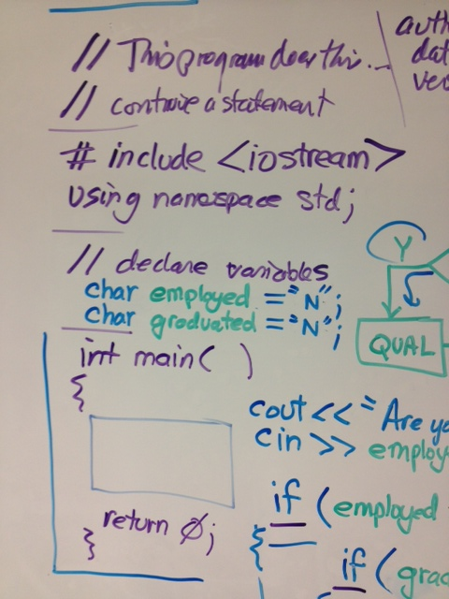
Let’s see how the flowchart above can be translated into C++ code. First start with a comment area to type in your name and title of the program and version and date, etc. – you can use /* for a comment with more than one line or // for a single line comment.

Then include the library functions you need. At the very least you will need the <iostream> one to include code that explains the cin and cout commands.

All programs must have a main function area – int main () –
With brackets to include all lines of code, plus return 0 at the end.

Any time you use a variable in your program you need to declare it. If your code does not assign it a value then you need to give it a value when you declare it (you initialize it).
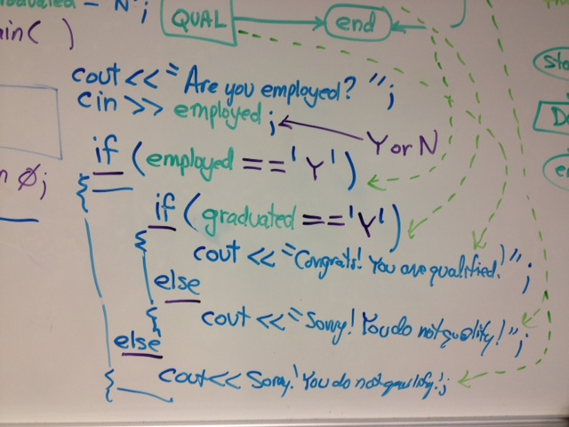
Then there is the code…

Does the code to the left really match the flowchart? How would you know? Remember that each symbol in the flowchart should be represented by one or more statements in the program code.

Notice that before you can make a decision about “Are you employed?” you need an answer so you have to ask the question.
How to you code a decision?
1
IF (this condition is true)
1
do this // “Y(es)” branch of decision
2
ELSE
2
3
do this instead // “N(o)” branch of decision
3
1
IF (Employed? is true/yes)
2
IF (Graduated? is true/yes) // “Y(es)” to Employed?
1
You are qualified! // “Y(es)” to Graduated?
3
ELSE
Sorry! You are not qualified! // “N(o)” to Graduated?
2
4
4
ELSE
5
Sorry! You are not qualified! // “N(o)” to Employed?
3

5

Can you find the numbered symbols in the code?
1
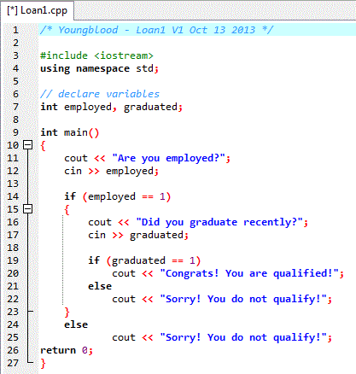
Here they are to the right…
2
4
3
3
5
If you have trouble running this program as it is above, try declaring “employed” and “graduated” as integer variables (int) rather than character variables (char) and typing the value 1 for “Y(es)” and 0 for “N(o).”

⬅ Here is the full program to the left.

Before you try it, let us recap what we have learned in this lesson so far:
- There is a minimum framework for each program that contains (a) comments about the program, (b) library functions needed, (c) a variable declaration area, and (d) a main function with return 0 statement.
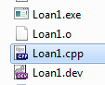
- The code you type is stored as a .cpp file. This is converted into an object file of 1s and 0s (machine code) with .o(bj) file extension. The file with .dev is a project that contains the Loan1 files. When you compile the code, which adds library functions, you create an executable file with .exe file extension that you can double click on to run the same as you can with the IDE or Word or games.
- Flowcharts are a tool for showing the logic of the program. Each symbol is represented by one or more statements of code.
- Decisions are programmed as IF…ELSE constructs like those we have worked with above.
PROBLEM: An applicant qualifies for a loan if they EITHER earn $35,000 a year OR they have been employed for 5 years.

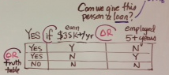
One of the ways to keep the logic straight in this problem is to create a truth table. Let’s interpret this:
--- If “Earn $35,000+/year?” is Y(es), even if “Employed 5+
1
Years?” if N(o), then “Loan?” is Y(es)
--- If “Earn $35,000+/year?” is N(o), but “Employed 5+
2
1
Years?” is Y(es) then “Loan?” is Y(es)
2
--- If both “Earn $35,000+/year?” is N(o) and “Employed 5+
3
3
Years?” is N(o) then “Loan?” is N(o)
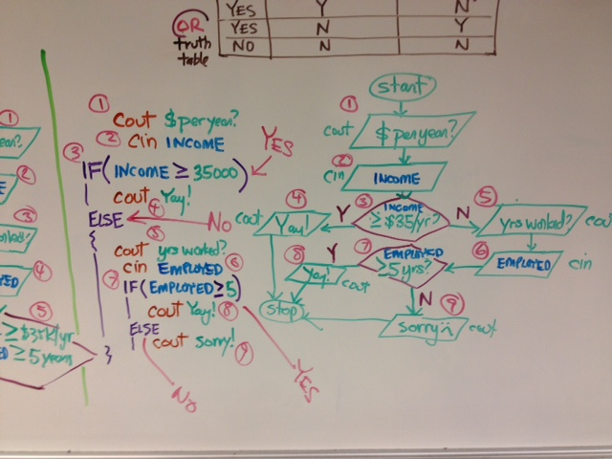
To the left is a flowchart that solves this problem. Can you create the code from this flowchart using the truth table above and the previous employed-graduated example (without looking at the answer on the next page)?
1
2
Hint:
5
- Start with the basic framework.
3
4
- Reserve enough lines for each of the flowchart symbols.
- Look for where the decisions are and construct IF…ELSE
6
7
statements for them.
8
- If there is more than one statement for IF or ELSE, be
sure to include them within brackets.
9
- Make sure all branches of the flowchart are covered.
- Account for the parallelograms inputs/outputs.

01
02
03
04
05
06
07
08
09
10
11
12
13
14
15
16
17
18
19
20
21
22
23
24
25
26
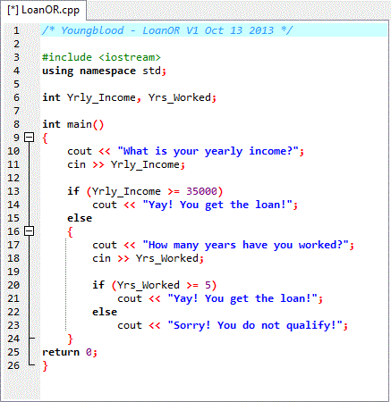
Here is one solution. Let’s break it down into its components:

Comments
Library routines (for cin and cout)
Variable declaration area

Main function

Get a value for yearly income

Decision if yearly income >= $35K
If yes, then the applicant qualifies…
If no, then…

Get a value for years worked

Decision if years worked >= 5
If yes, then applicant qualifies…
If no, then the applicant does not qualify.

End program

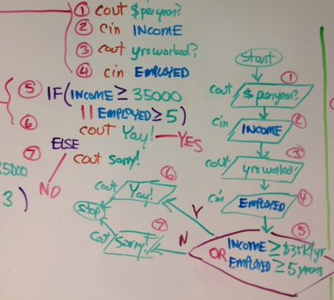
Here is another solution to the problem that uses one decision with a logical OR instead of two separate decisions.

Note the changes in the flowchart. You want to ask for income and years worked first before making the decision about whether “Is income >= $35K? OR Is (years) Employed >= 5?”

When this is converted to code, note that the code for OR is || and is placed between the two conditions.

According to the truth table, if either of these conditions is true then the answer to the entire condition is Y(es) and the applicant gets the loan. If both of the conditions are false, then the entire condition is N(o) and the applicant is not qualified for the loan.

The last type of decision construct we studied was the SWITCH…CASE statement that is used when there are many answers (logical branches) to a condition or question.

PROBLEM: There are three doors. You are to choose one of the doors. Behind one of the doors is a prize (a car) that you win if you choose the correct door.
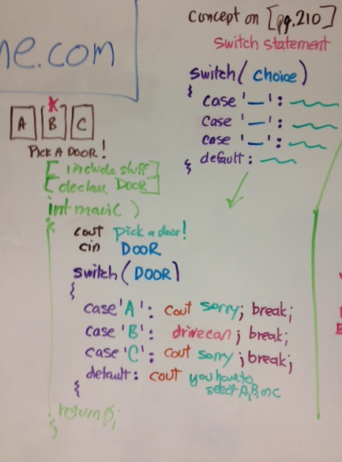
Note the structure of the SWITCH…CASE statement to the left where there is some variable (“choice” in this case) with an integer value. For each of the values of the variable you can have a set of instructions that can be complex as needed.

The flowchart is nearly the same as the two answer solution expressed as the IF…ELSE construct:

choice?

A
B
C
default

The value for the DOOR variable has to be an integer so you either have to guess 1, 2, or 3 instead of A, B, or C or else you have to set up a way (such as IF…ELSE statements) that change the A, B, or C answers to 1, 2 or 3.
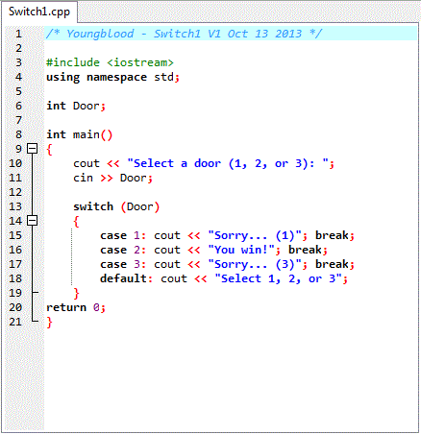

Notice that the basic framework is here as they are for all of the other programs.

Can you suggest some other examples that we can use for SWITCH…CASE statements?

What further lessons have we learned?
- Logical operators such as OR (||) or AND (&&) or NOT (!) can be used to collect one or two or several conditions into one.
- Truth tables can help to make sure that the answers to these complex conditions are represented correctly.
- The SWITCH…CASE construct can be used if there are several answers to a condition/question than can be expressed as integers.

